Speaking Part 1.2 - Multi-Level (New Format)
Pictures + Questions + Sample Answers

1. Countryside and city
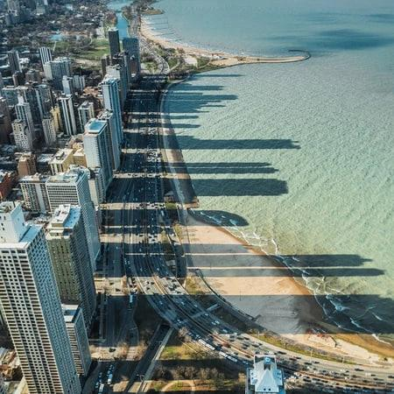 | 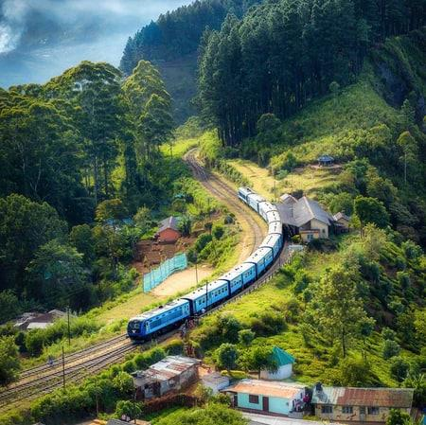
Questions:
- What do you see in these pictures?
Sample answer: In the first picture we can see a quiet village surrounded by green fields, where people seem to live a slow-paced life. The second picture, on the contrary, shows a modern city with skyscrapers, busy roads and crowds of pedestrians. So basically, one image represents rural life while the other reflects urban lifestyle.
- What is the difference between living in the city and in the countryside?
Sample answer: Well, the main difference lies in the pace of life and available facilities. City dwellers have better access to education, healthcare and entertainment, but they constantly deal with noise, traffic congestion and air pollution. Rural life, on the other hand, offers fresh air, peace and closer community ties, although job opportunities there are quite limited.
- Where do you prefer to live, in the city or village?
Sample answer: Personally, I would choose the city because everything is within walking distance and there are far more career prospects for young people. However, I must admit that city life can be exhausting, so ideally I would live in the city on weekdays and escape to the countryside at weekends to recharge my batteries.

2. Exercising Sport
 | 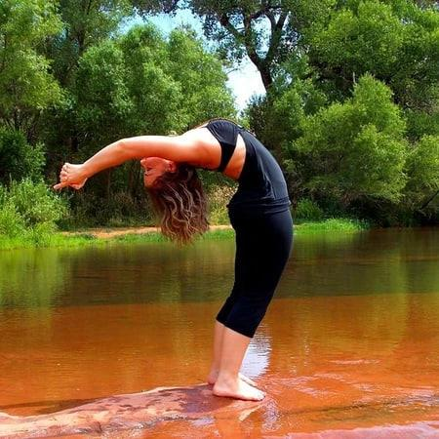
Questions:
- What are the people in these photos doing?
Sample answer: In the first photo, some people are working out in a gym, lifting weights and running on treadmills. In the second one, a group of people seems to be playing an outdoor game, probably football or basketball. Generally speaking, both pictures show people doing physical activities in order to stay fit and healthy.
- What are the benefits of doing sport?
Sample answer: There are countless benefits, actually. First of all, regular exercise strengthens our muscles and immune system, so we fall ill less often. Secondly, when we work out, our brain releases endorphins, the so-called happy hormones, which reduce stress and anxiety. Besides, team sports teach us discipline, cooperation and time management skills.
- What sports are popular in your country?
Sample answer: In Uzbekistan, football is definitely the most popular sport; almost every boy grows up playing it in the neighbourhood. Wrestling is also part of our national culture, and traditional kurash competitions attract huge audiences. Nowadays fitness and volleyball are becoming increasingly popular among young people as well, especially in big cities like Tashkent.

3. Jobs and Occupations
 | 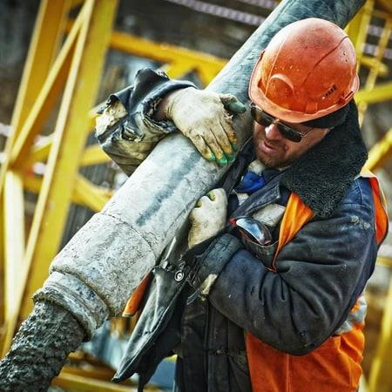
Questions:
- Who can you see in these pictures?
Sample answer: In the first picture I can see an office worker, most likely sitting in front of a computer and dealing with paperwork. The second picture shows a manual worker who seems to be doing some kind of physical labour, perhaps at a construction site. They represent two completely different types of occupations.
- What difficulties do they face?
Sample answer: Each job has its own challenges, I suppose. Office workers often suffer from stress, tight deadlines and sitting for long hours, which damages their eyesight and posture. Manual workers, meanwhile, risk their health and safety since their jobs involve heavy lifting, dangerous tools and harsh weather conditions. Both require either mental or physical endurance.
- What is the difference between the jobs in the pictures?
Sample answer: The key difference is mental versus physical work. The office job requires qualifications, computer skills and concentration, but it offers a comfortable environment and a stable salary. The manual job, by contrast, demands strength and practical skills, usually pays less and involves more risks. However, honestly speaking, both are essential for our society.

4. Holidays
 | 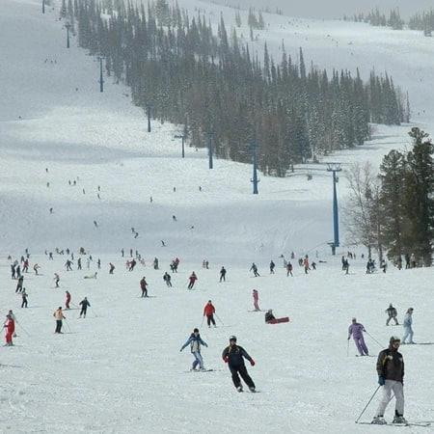
Questions:
- Describe these holiday locations in the pictures.
Sample answer: In the first picture there appears to be a seaside resort with golden beaches, palm trees and tourists sunbathing. The second one looks like a mountain area covered with forests, which seems perfect for hiking and camping. In other words, one location offers relaxation by the water, while the other is ideal for active holidays in nature.
- Which of these places is better to spend a holiday?
Sample answer: It really depends on what you expect from your vacation. If someone wants to simply unwind, sunbathe and forget about work, the beach is the obvious choice. But if you are keen on adventure, breathtaking views and fresh air, then mountains would suit you better. As for me, I prefer the sea because swimming helps me truly relax.
- Is it important to have holidays?
Sample answer: Absolutely, holidays are essential rather than a luxury. We live in a fast-moving world where people face stress and burnout almost every day, so taking regular breaks allows both our body and mind to recover. Moreover, holidays give us precious time to spend with family and friends, which strengthens our relationships.

5. Eating
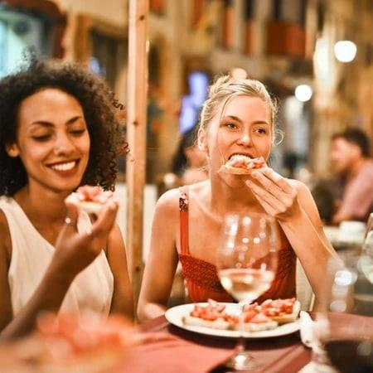 | 
Questions:
- What can you see in these pictures?
Sample answer: In the first picture, I can see a family having a home-cooked meal around the table. The second picture shows people eating out, probably in a restaurant or cafe. So the images basically illustrate two different ways of having food: homemade meals versus dining out.
- What is the difference between eating at home and eating out?
Sample answer: Eating at home is definitely cheaper and healthier, because you control the ingredients and hygiene yourself. Eating out, on the other hand, saves time and gives you a chance to try exotic dishes that you cannot cook. However, restaurant food tends to contain more fat, salt and sugar, plus the service always adds extra cost.
- What are the advantages of eating out?
Sample answer: The main advantage is convenience; there is no shopping, cooking or washing up afterwards, which is perfect for busy people. In addition, restaurants offer a wide variety of cuisines, so you can taste Italian, Korean or Turkish dishes whenever you want. And of course, eating out is a social activity that brings friends and relatives together.

6. Business
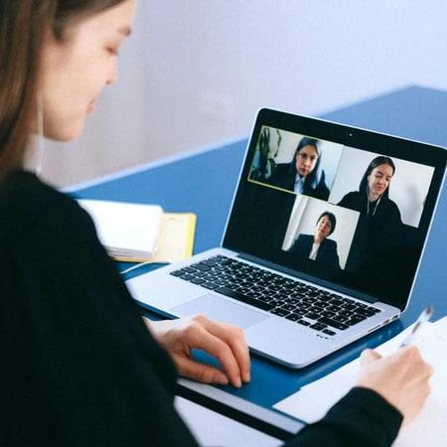 | 
Questions:
- Describe what you see in the pictures.
Sample answer: In the first picture we can see employees working remotely, probably from home, communicating through laptops and video calls. The second picture shows a traditional office environment where colleagues work side by side. Essentially, the images compare remote working with the conventional workplace.
- What are the differences between remote working and working at workplaces?
Sample answer: Remote working offers flexibility: you save commuting time and can organise your day as you wish. Working in an office, however, provides direct communication with colleagues, instant support from managers and a clear boundary between work and private life. So the former gives freedom while the latter gives structure and team spirit.
- Why do many people today want remote working?
Sample answer: I believe the main reason is convenience. People waste hours stuck in traffic every day, and working from home eliminates that completely. Besides, employees can balance work with family responsibilities and even relocate to quieter, cheaper areas. After the pandemic proved that remote jobs can be productive, this trend has only grown stronger worldwide.

7. Rush Hour
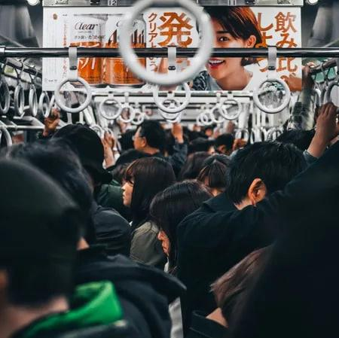 | 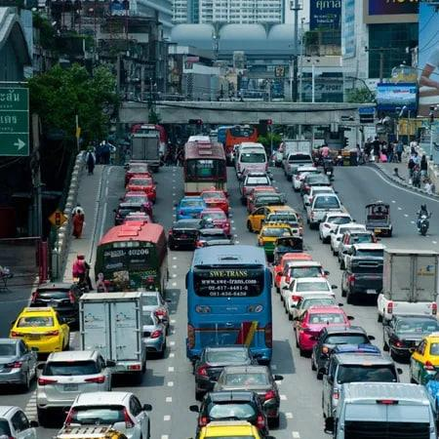
Questions:
- What can you see in the pictures?
Sample answer: Both pictures apparently show rush hour in a big city. In the first one, crowds of people are standing in an overcrowded bus or metro carriage, while in the second, cars are stuck in a long traffic jam with drivers looking stressed. It is a typical scene during morning and evening peak times.
- Do you prefer public or private transport for commuting?
Sample answer: Although travelling by my own car would be more comfortable, I generally prefer public transport for daily commuting. First, it is much cheaper if you consider fuel and parking prices. Second, I can read or listen to podcasts instead of concentrating on the road. The only downside is overcrowding during rush hours, but the advantages outweigh it.
- How can traffic jams be solved?
Sample answer: This problem requires several measures at once. Governments should invest in affordable and efficient public transport so that fewer people use private cars. Building ring roads, bridges and developing cycling infrastructure would also help. Additionally, encouraging carpooling and introducing flexible working hours could reduce the number of vehicles on the road at peak times.

8. Watching Movies
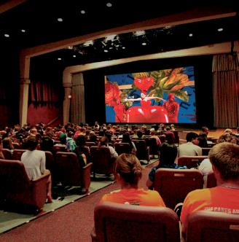 | 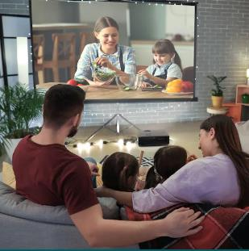
Questions:
- What can you see in the pictures?
Sample answer: In the first picture, a group of friends seems to be watching a film at home, comfortably lying on a sofa. The second picture shows people in a cinema hall in front of a huge screen. So both images are about watching movies, just in different settings.
- Why do some prefer to watch at home while others in cinema?
Sample answer: Watching films at home is cheap and comfortable; you can pause whenever you want and eat whatever you like. Cinema fans, on the other hand, argue that nothing compares to the giant screen, powerful sound effects and special atmosphere. For many people, going to the movies is also a social event, not just entertainment.
- What sorts of movies do you often watch?
Sample answer: To be honest, I am really into science fiction and detective stories because they keep me on the edge of my seat from start to finish. Occasionally I watch comedies with friends just to lift our mood after a stressful week. I rarely choose horror films, though, as they affect my sleep badly.

9. Shopping
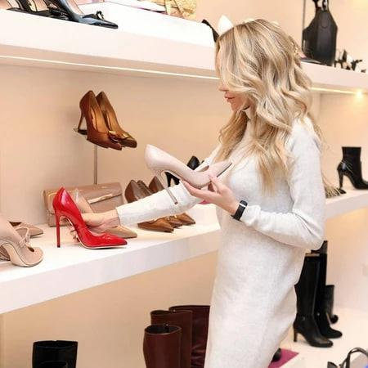 | 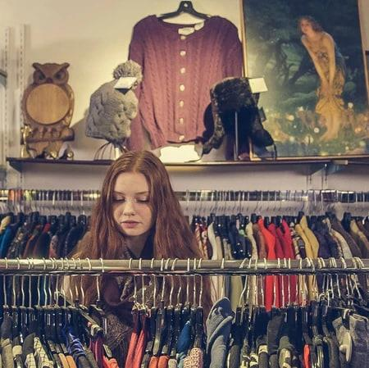
Questions:
- Compare these pictures.
Sample answer: The pictures show two different shopping experiences. In the first one, a person appears to be shopping online using a smartphone or laptop, while in the second, someone is choosing goods in a physical store. One image represents e-commerce, and the other traditional brick-and-mortar shopping.
- In which picture is the person facing a more difficult choice?
Sample answer: I would say the person in the actual shop faces a more difficult choice. When you shop online, filters and customer reviews help narrow down the options quickly. In a real store, however, you are surrounded by attractive products, sales assistants offering help and eye-catching displays, which makes resisting temptation and deciding much harder.
- Do you like shopping?
Sample answer: It depends on what I am buying, to tell the truth. Shopping for gadgets or clothes can be quite enjoyable, especially with friends. But grocery shopping feels like a boring routine to me, so I usually do it online. All in all, I would describe myself as a moderate shopper, not a shopaholic at all.

10. Shopping for Food
 | 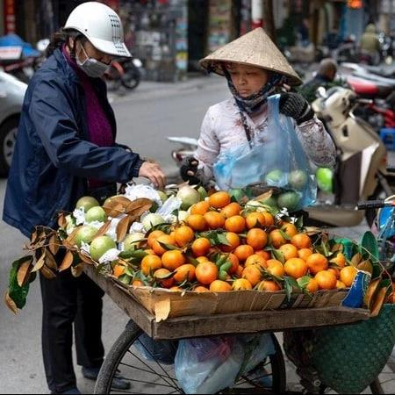
Questions:
- Describe the pictures.
Sample answer: In the first picture, a customer seems to be buying fresh fruit and vegetables at an open market directly from sellers. The second picture shows shelves full of packaged products in a supermarket. Basically, the images contrast traditional marketplaces with modern self-service stores.
- Where do you usually buy groceries?
Sample answer: Mostly at the supermarket near my house, because it is convenient: everything from bread to cleaning products is under one roof, and the prices are clearly labelled. But when it comes to fruit and vegetables, I prefer the local bazaar, since produce there is fresher, tastier and often cheaper than the packaged equivalents.
- What is the difference between shopping at supermarkets and at markets?
Sample answer: Supermarkets win in terms of comfort and choice; they have fixed prices, receipts and everything in one place. Markets, on the other hand, offer fresher seasonal produce and a chance to bargain, which makes shopping there more interactive. Besides, at markets you can actually talk to the growers themselves, which builds trust.

11. Free Time
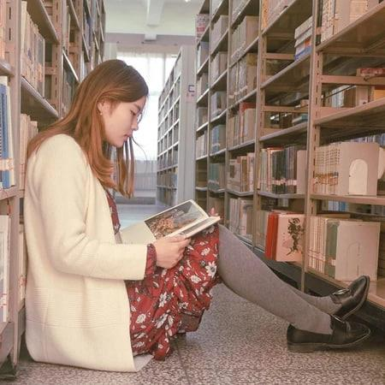 | 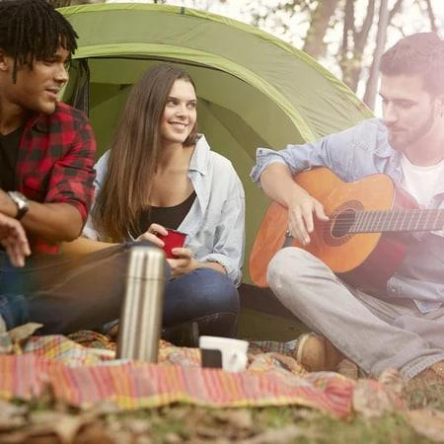
Questions:
- Compare the first picture to the second.
Sample answer: The first picture shows someone spending leisure time actively, doing some kind of outdoor activity or sport, whereas in the second picture a person is relaxing indoors, probably surfing the internet or watching TV. In short, one way of spending free time is active and the other is passive.
- How do you usually spend your free time?
Sample answer: It varies depending on my mood and the weather. On weekdays I only have a couple of free hours, so I mostly read books or watch educational videos. At weekends, however, I try to meet friends, play football or go for a bike ride. Sometimes I also help my parents around the house.
- What are the pluses and minuses of spending free time in these ways?
Sample answer: Active leisure obviously keeps you fit and energised, but it can leave you physically tired. Passive activities like scrolling through feeds or binge-watching help you unwind quickly, yet they do not really recharge you; ironically, you often end up feeling even lazier and less motivated. That is why experts recommend combining both sensibly.

12. Cycling
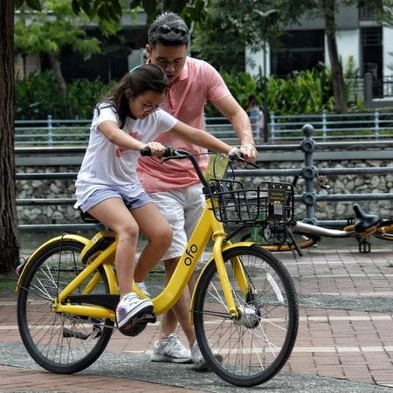 | 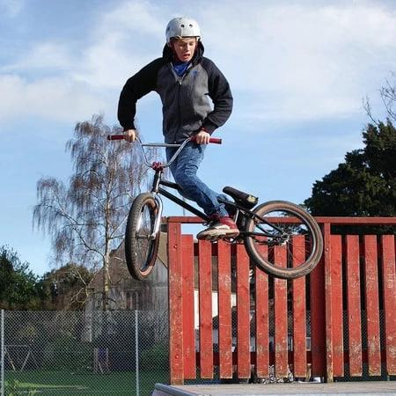
Questions:
- Compare the way people ride bikes in the pictures.
Sample answer: In the first picture, cyclists appear to be riding in a park or on a special bike lane, enjoying a casual ride. In the second one, a cyclist seems to be riding in heavy traffic or competing in a race. So one image shows cycling as recreation, while the other presents it as transport or sport.
- What are the benefits of biking?
Sample answer: Cycling benefits both individuals and society. It is a brilliant cardio workout that strengthens the heart and leg muscles without putting pressure on the joints. Environmentally, bicycles produce zero emissions, reducing air pollution and noise. Economically, cycling saves money on fuel and parking, and it often gets you through congested streets faster than cars.
- Why do many people want to ride bikes today?
Sample answer: I think health consciousness plays the biggest role; people finally understand how harmful a sedentary lifestyle is. Rising fuel prices matter too, as cycling is virtually free. Plus, many cities are building dedicated bike lanes nowadays, making roads safer for cyclists, and electric bikes have made riding accessible even for older people.

13. Manual Work
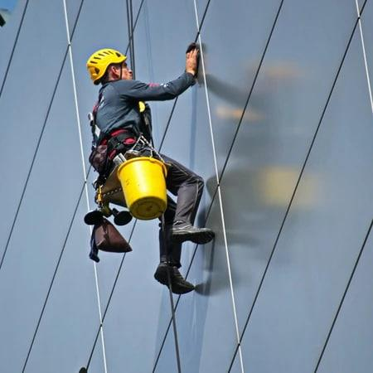 | 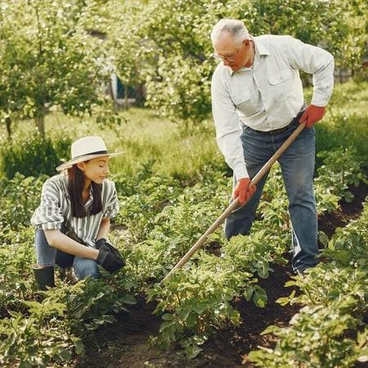
Questions:
- What can you see in these pictures?
Sample answer: In the first picture I can see builders or construction workers performing physically demanding tasks, possibly laying bricks. The second picture shows another type of manual worker, maybe a farmer or a mechanic, busy with hands-on labour. Both images depict hard physical work done by ordinary people.
- What are the difficulties of these jobs?
Sample answer: Such jobs are extremely tough, no question about it. Workers have to operate in freezing winters and scorching summers, lift heavy loads and stand all day, which leads to back problems and injuries over time. What is more, despite the exhausting nature of the work, manual labourers are often underpaid and undervalued by society.
- What are the benefits of these jobs?
Sample answer: Surprisingly, there are some. Physical work keeps the body strong and active compared to sitting at a desk all day. These jobs also provide a stable income without requiring expensive university degrees, and there is genuine satisfaction in seeing tangible results of your effort, such as a built house or a harvested field. Skilled tradespeople are always in demand, too.

14. Cooking
 | 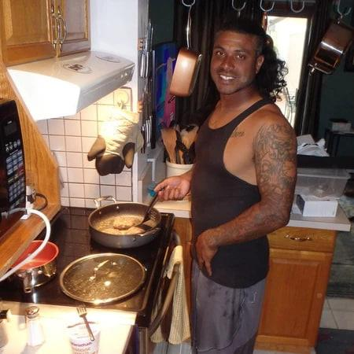
Questions:
- Compare the pictures and say what you can see.
Sample answer: As far as I can see, in the first picture a person is cooking a meal at home in the kitchen, while in the second, people appear to be eating at a restaurant served by waiters. So the pictures illustrate preparing your own food versus dining out.
- What are the advantages and disadvantages of cooking for yourself and eating out?
Sample answer: Cooking yourself is economical and healthy, because you know exactly what goes into your dish. Its main drawback is the time and effort involved. Eating out saves that time and offers variety, but it costs significantly more, and you can never be completely sure about the quality of the ingredients used behind the kitchen doors.
- Do you often cook for yourself?
Sample answer: Yes, quite regularly, actually; I would say five or six days a week. My signature dishes are simple things like fried rice and pasta, and plov on special occasions. Cooking helps me switch off after a long day, and frankly speaking, homemade food always tastes better. I usually order delivery only when I am pressed for time.

15. Animals
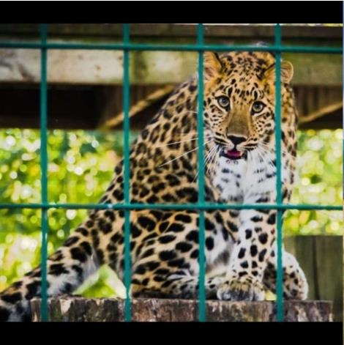 | 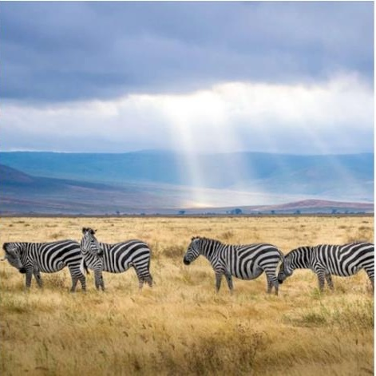
Questions:
- Describe the animals in the pictures.
Sample answer: In the first picture, wild animals can be seen walking around an enclosure, probably in a zoo or safari park. The second picture shows similar animals living freely in their natural habitat. So the images essentially contrast animals kept in captivity with those living in the wild.
- What are the advantages and disadvantages of keeping animals in captivity?
Sample answer: On the positive side, zoos protect endangered species from poachers, conduct important research and educate visitors, especially children. On the negative side, cages and small enclosures deprive animals of freedom and natural behaviour, causing them stress and suffering. Ideally, modern zoos should recreate habitats as spacious and natural as possible.
- Do you support zoos which keep animals captive?
Sample answer: I have mixed feelings, to be honest. Well-managed zoos that focus on conservation and breeding programmes genuinely save species from extinction. However, roadside menageries that keep animals purely for profit in terrible conditions should definitely be banned. Overall, I support only those facilities where animal welfare clearly comes before entertainment.

16. Transportation
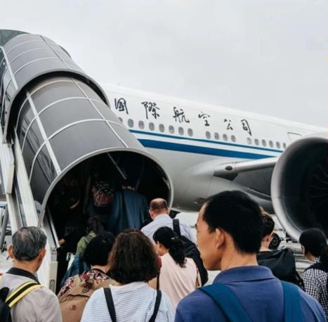 | 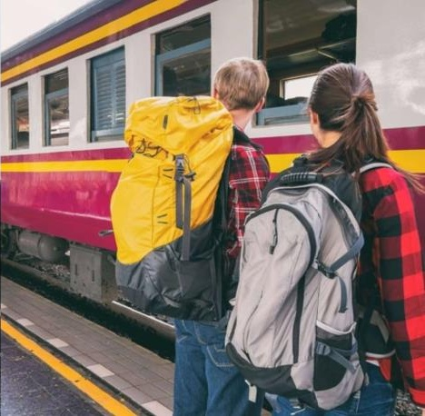
Questions:
- What can you see in these pictures?
Sample answer: In the first picture there is a plane or a train, judging by the setting, while the second shows cars moving along a highway. Generally speaking, the images represent different means of transport, probably air or rail travel versus road transport.
- Which transportation do you prefer?
Sample answer: For long distances I would certainly pick the train, because you can walk around, enjoy the scenery and sleep comfortably, unlike in cramped planes. Within the city, though, the metro works best for me since it is fast and immune to traffic jams. Cars are convenient for families, but parking and petrol make them expensive these days.
- What are the advantages of road transport and air transport?
Sample answer: Road transport offers door-to-door delivery and total flexibility; you can set off whenever you like without following timetables. Air travel, on the other hand, is unbeatable in speed: a journey that takes days by car takes merely hours by plane. Essentially, roads win on short trips, while aviation dominates long-distance travel.

17. Houses and Flats
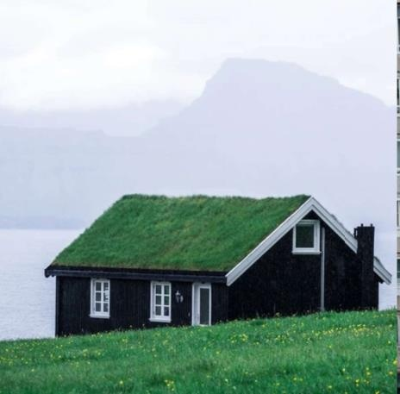 | 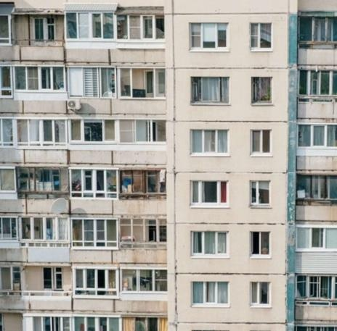
Questions:
- What can you see in the pictures?
Sample answer: The first picture appears to show a private house with a garden and a yard, while the second depicts blocks of flats in a residential area. In other words, the images compare suburban or village housing with typical urban apartment living.
- Do you prefer to live in a house or in a flat?
Sample answer: At this stage of my life, a flat suits me better because it is easier to maintain, safer when I travel, and usually located closer to work and university. Still, my dream is to build a house someday, with a garden where I could grow vegetables and invite friends for barbecues.
- Why do many people like to stay in a house?
Sample answer: Mainly for space and privacy, I suppose. House owners do not share walls with noisy neighbours, have their own parking and enjoy outdoor areas for children and pets. A house is also a long-term investment that can be extended or redesigned freely. Plus, for many people it symbolises independence and stability in life.

18. Animals World
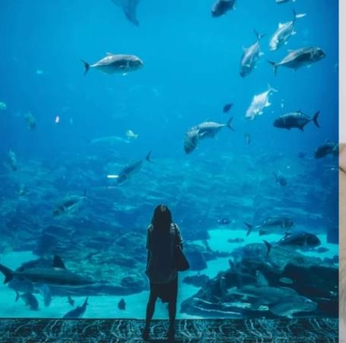 | 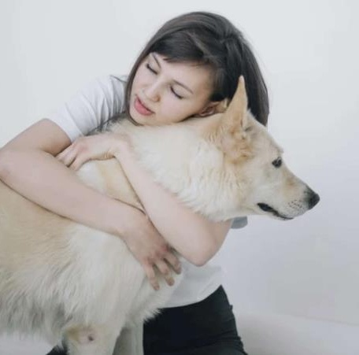
Questions:
- Describe the pictures.
Sample answer: The pictures show underwater life, as far as I can tell: colourful fish swimming among coral reefs and other marine creatures. The scenes look absolutely fascinating, capturing the beauty of the ocean world that we rarely get to observe in everyday life.
- Do you like marine life?
Sample answer: Definitely, I find it mesmerising. The ocean hides creatures that look almost alien, such as glowing fish, giant octopuses and coral reefs teeming with life. I never miss documentaries about the deep sea. Sadly, plastic pollution is threatening this amazing world, so I try to reduce single-use plastics in my daily life.
- Do you keep a pet?
Sample answer: Yes, I have a cat that practically rules the whole house, honestly speaking. Looking after her has taught me responsibility and routine, including feeding, grooming and playing with her every day. Pets also reduce stress remarkably; stroking a cat after a hard day works better than any medicine, in my experience.

19. Music
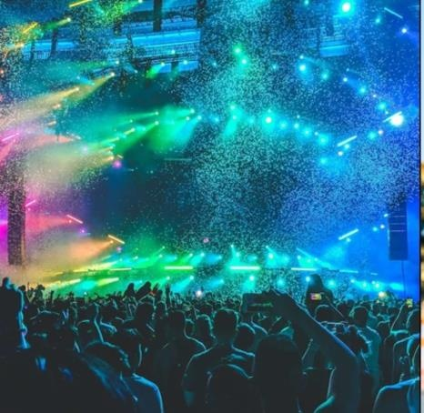 | 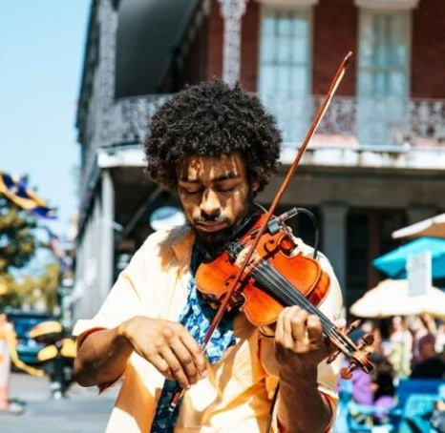
Questions:
- What can you see in the pictures?
Sample answer: In the first picture, musicians appear to be performing live on stage with instruments, surrounded by an excited crowd. The second picture shows someone listening to music alone through headphones. So the images contrast live concerts with personal listening experiences.
- Can you play music?
Sample answer: A little, yes. I learned basic guitar chords at school and can play a few popular songs, though far from professionally. I am planning to take proper lessons soon, because playing an instrument, as research shows, improves memory, coordination and even mathematical thinking. It is also a wonderful way to entertain friends.
- Do you like live concerts?
Sample answer: I absolutely love them! Nothing compares to the electrifying atmosphere of a stadium: thousands of voices singing along, incredible sound energy and that special connection with the artist. Recordings cannot reproduce that feeling, no matter how good your headphones are. The only downsides are ticket prices and crowds, but the experience is totally worth it.

20. Online and Traditional Classes
 | 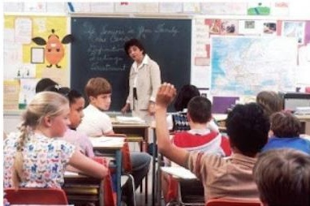
Questions:
- Can you describe these pictures?
Sample answer: In the first picture, students are attending a lesson online; each of them is sitting in front of a screen, probably at home. The second picture shows a traditional classroom where a teacher is explaining the topic at the blackboard. The images compare distance learning with face-to-face education.
- What are the advantages and disadvantages of online studying?
Sample answer: Online learning is flexible and accessible: you can study from anywhere, rewatch recorded lectures and often pay lower fees. Its drawbacks, however, include weak motivation, technical issues and the lack of real communication, which many students find demotivating. Practical subjects such as chemistry or medicine are also extremely hard to master remotely.
- Why do many students prefer studying online than face-to-face?
Sample answer: Firstly, it saves enormous amounts of time and money on commuting and accommodation. Secondly, shy students participate more actively in chat discussions than they ever would in a real classroom. Finally, digital platforms allow learners to combine studies with work and pause lessons whenever needed, and that level of control is simply impossible offline.

